Menu and UI designs

In this document I will outline the designs of the menu and UI systems for the Android version of the game. The PC version will be similar with minor adjustments, the main difference will be the lack of on-screen controls and a dedicated options menu.

Main Menu

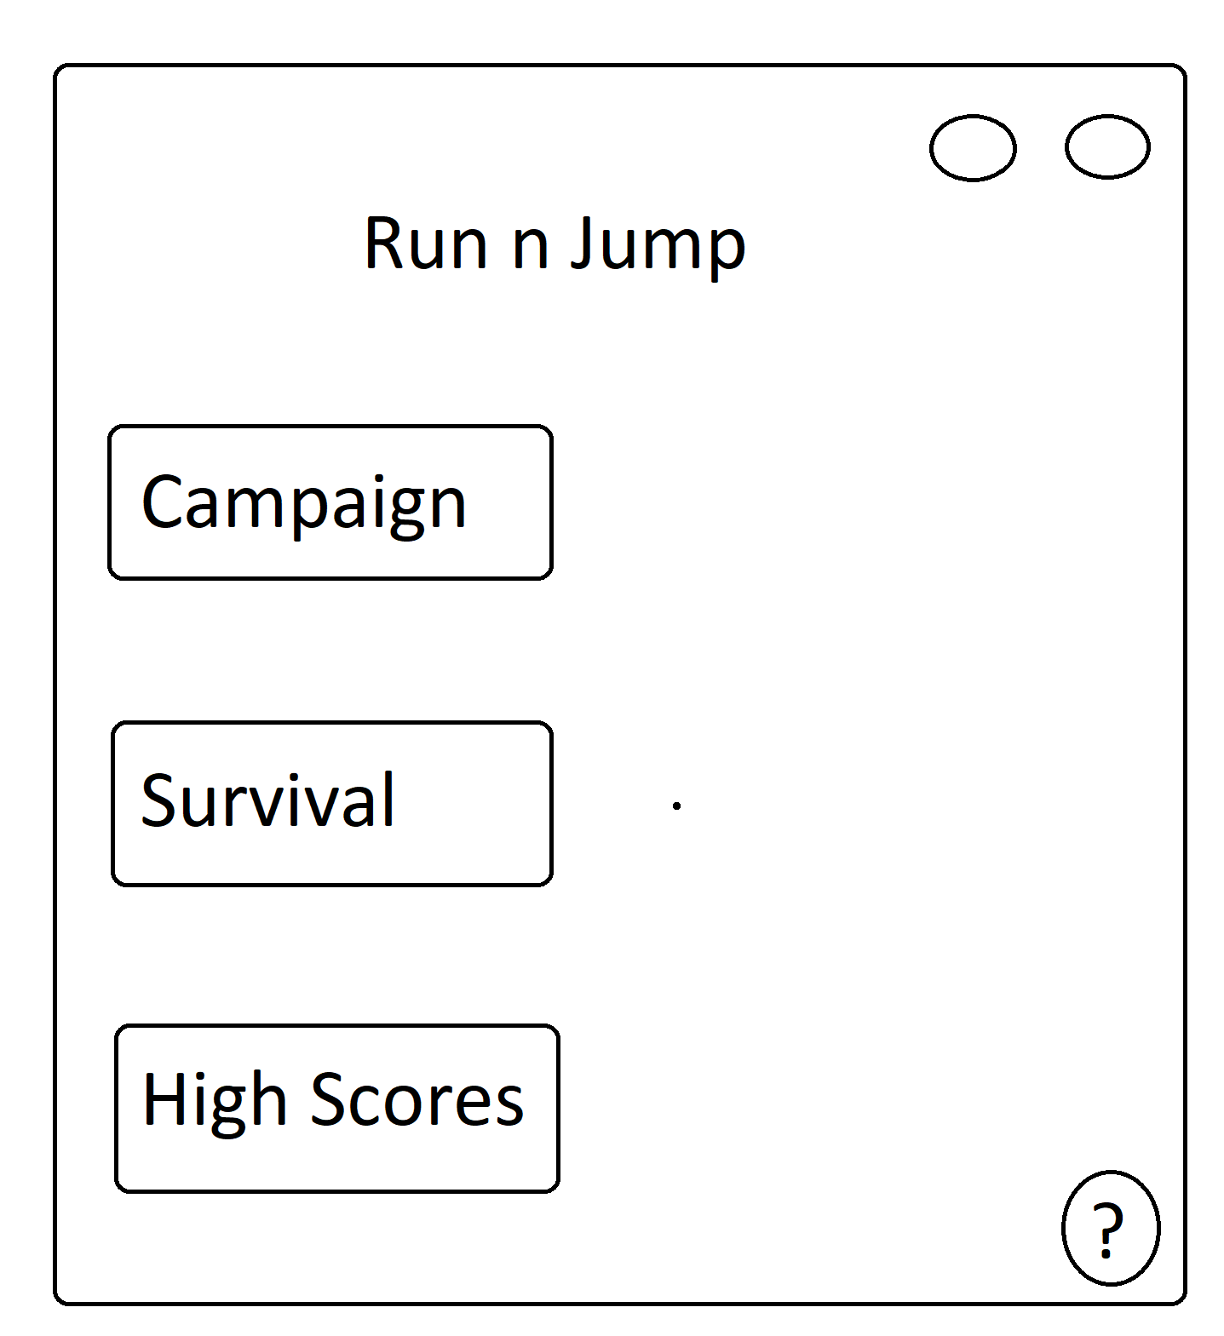

This drawing shows the rough design of the Main Menu - the screen the user sees upon launching the game application.

The circles in the top right of the screen represent the buttons to mute/un-mute music and sound effects. They will appear on most game screens with the same functionality.

The bottom right circle with a question mark opens a pop-up which explains the goal of the game and how to play.

The ‘Campaign’ square indicates a button which takes you to the level select screen.

The ‘Survival’ button starts the endless game mode. Takes you right into the game.

The high scores button leads the user o the high scores window.

Campaign Level Select

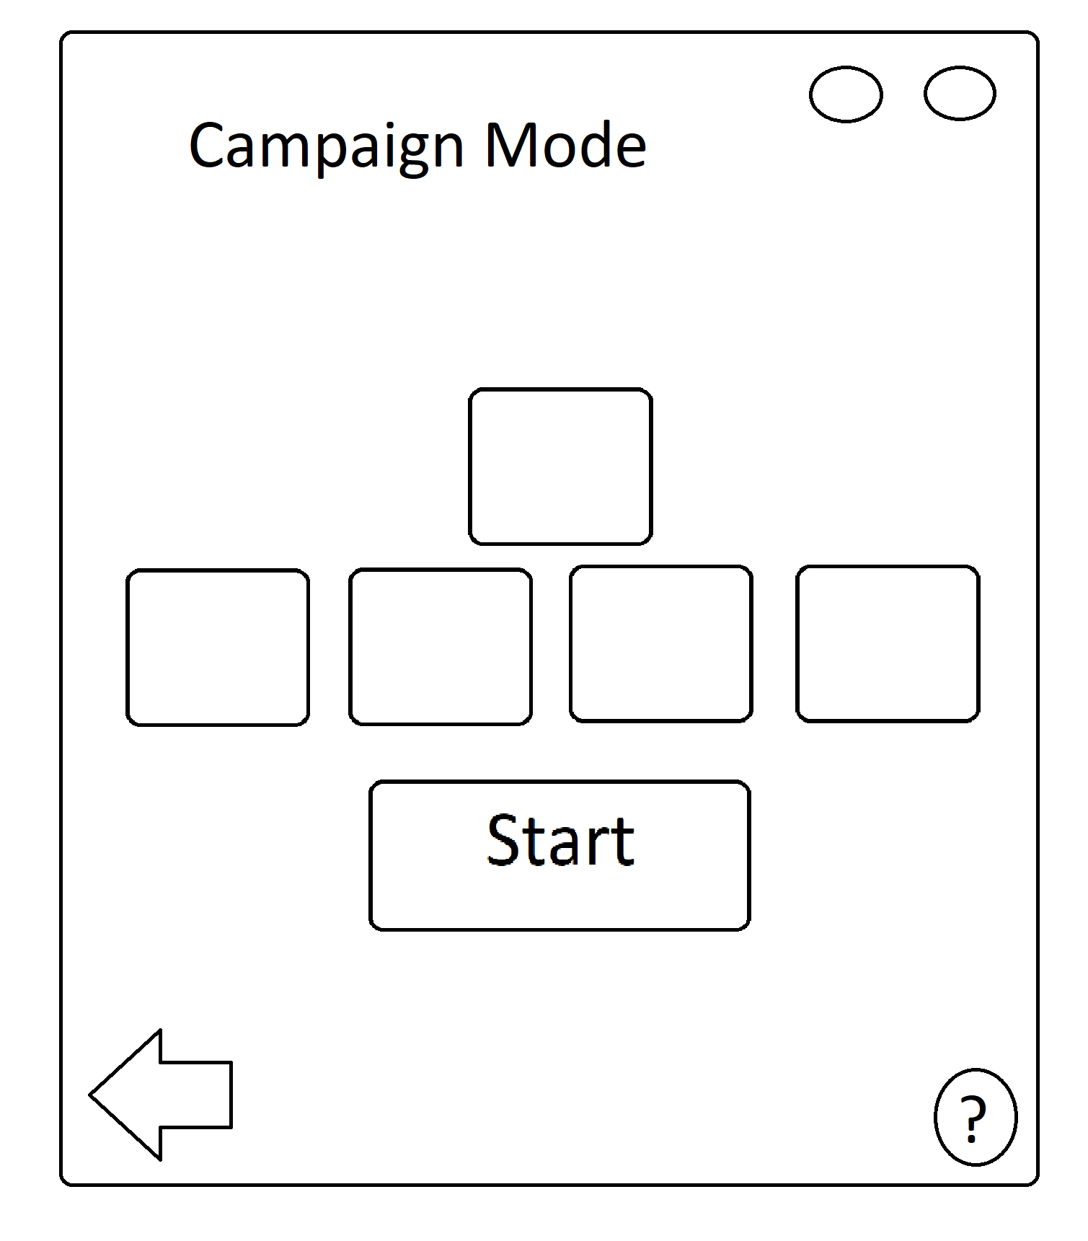

This is the campaign mode level select window. The levels need to be completed sequentially, to play the 2nd level the player has to have completed the first level first.

The empty squares are the levels, unlocked levels will be lightly coloured whereas locked level will have a lock on them and be shaded. To play a level the player needs to select the level and then click start.

The arrow is a button which returns the user to the main menu screen.

High Scores

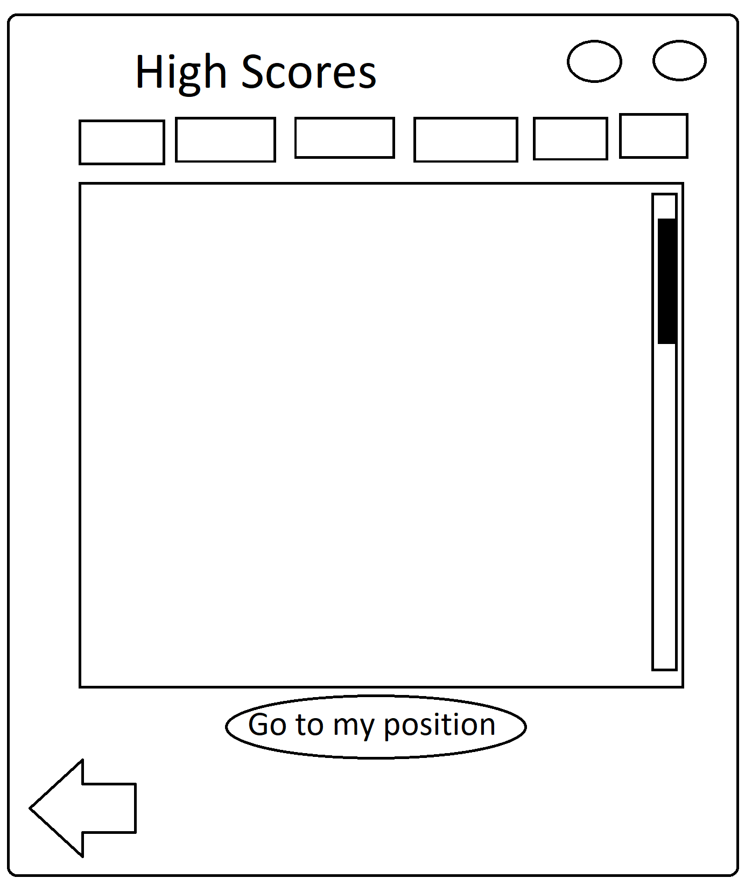

This is the high scores window which shows the all time highest scores or each level or game mode.

The squares at the top are the buttons which indicate the level or endless game mode. Upon being clicked it will show the highest scores for that level/game mode.

The big square indicates where the scores show up, this will be in the form of a scrollable list.

The go to my position button will show the player’s highest position for that level/game-mode by scrolling down to it automatically.

In game UI

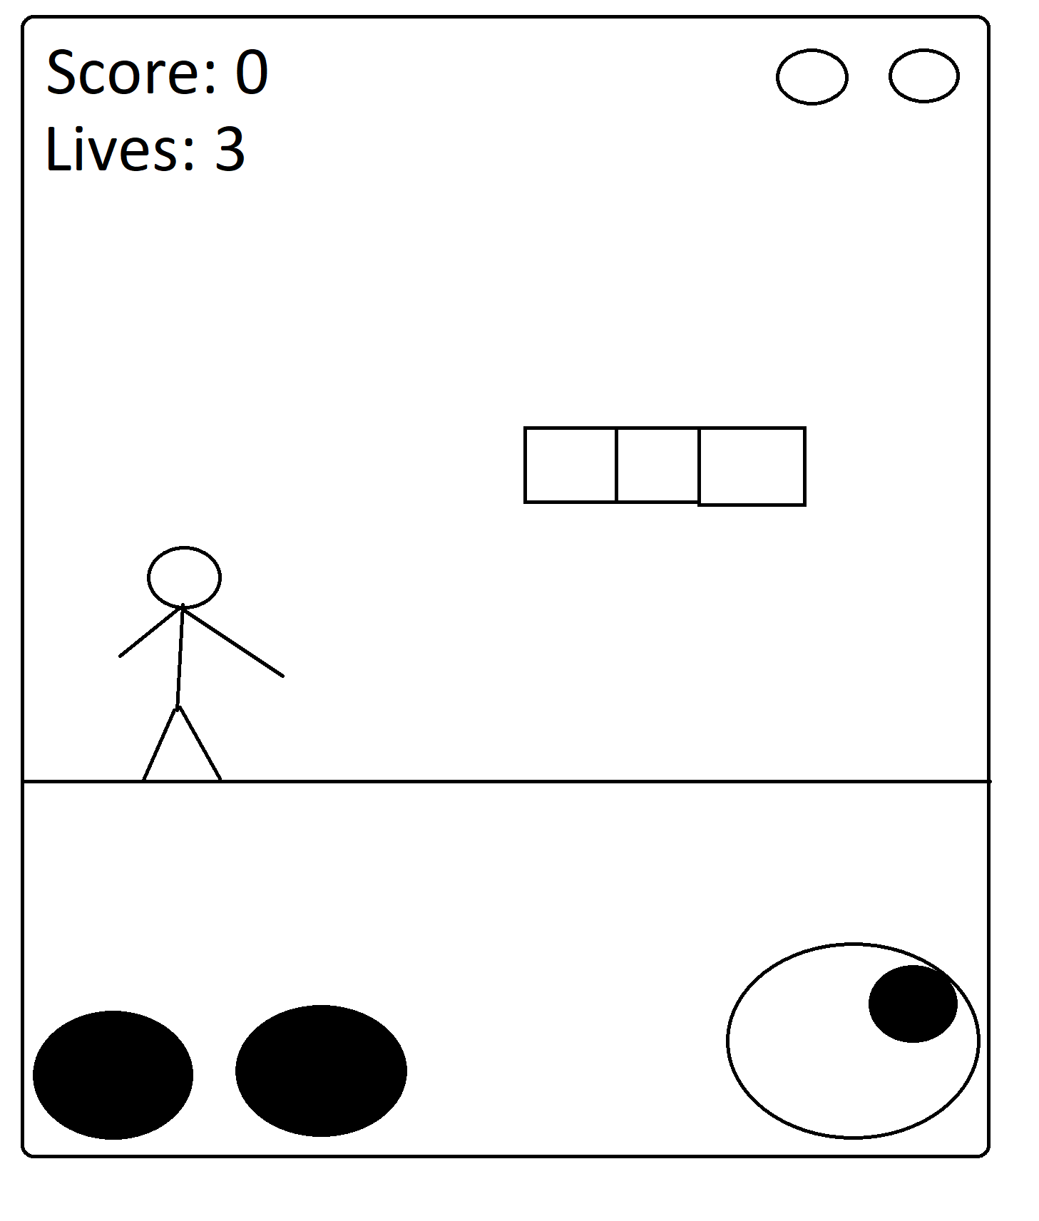

This is the in game UI, the bottom dark circles indicate the JUMP and INTERACT buttons. The jump button makes the player character jump, the interact button allows for the collection of power-ups and other interactions with the game world.

The dark circle inside the bigger circle in the bottom right corner indicates the on-screen touch joystick controls which allows the user to move the player character.